**Department of Information Systems and Cyber Security University of Texas in San Antonio**



IS 3413: Telecom and Networking-001, Fall, 2022

Name: Daniel Cook  
UTSA ID: dhz799  
Email address: *danielwcook5@gmail.com*

Lab Assignment: Lab: M02 – Application Protocols  
Date Due: 9/10/2022  
Date Submitted: 9/10/2022

Section A, Question 1: List the information in the SMTP header (To, From, Date, Subject and Message-ID).

From the student with the following email address to the teacher’s email address. The subject is “Class information” with the date “Sat, 27 November 2010 at 18:00:52”. With the following message ID below the date.

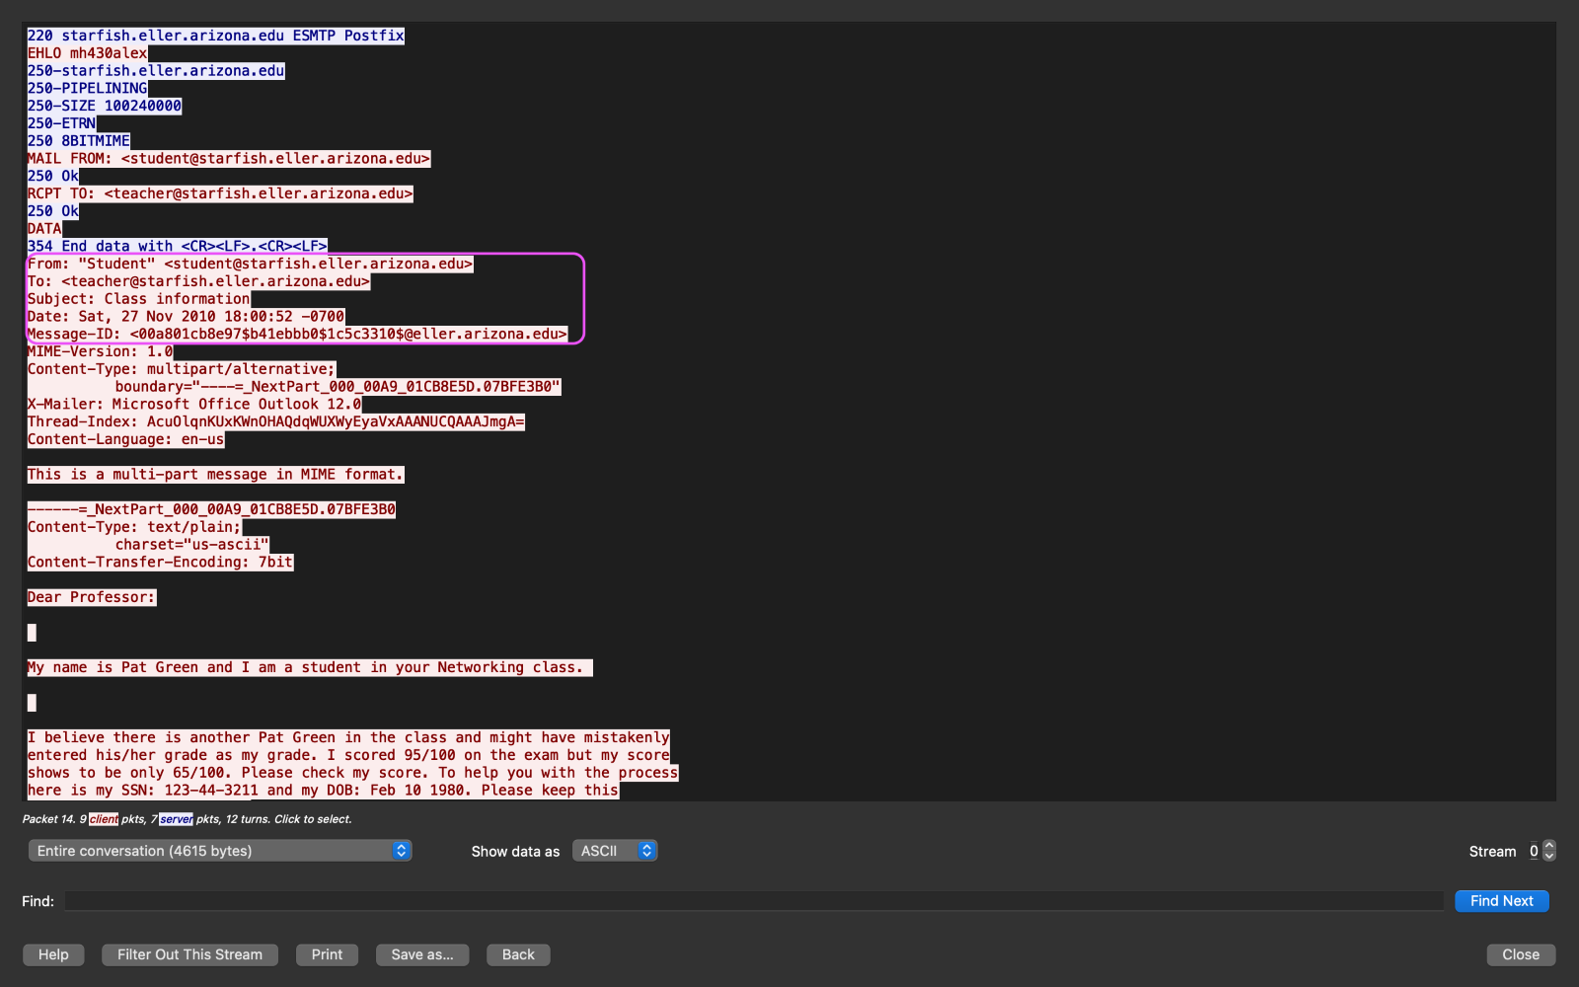  
Section A, Question 2: Find the sender’s message. List the user’s actual name, birth date and social security number.

The name of the student is Pat Green. The social security number is ‘123-44-3211' and the date of birth is ‘February 10, 1980’.

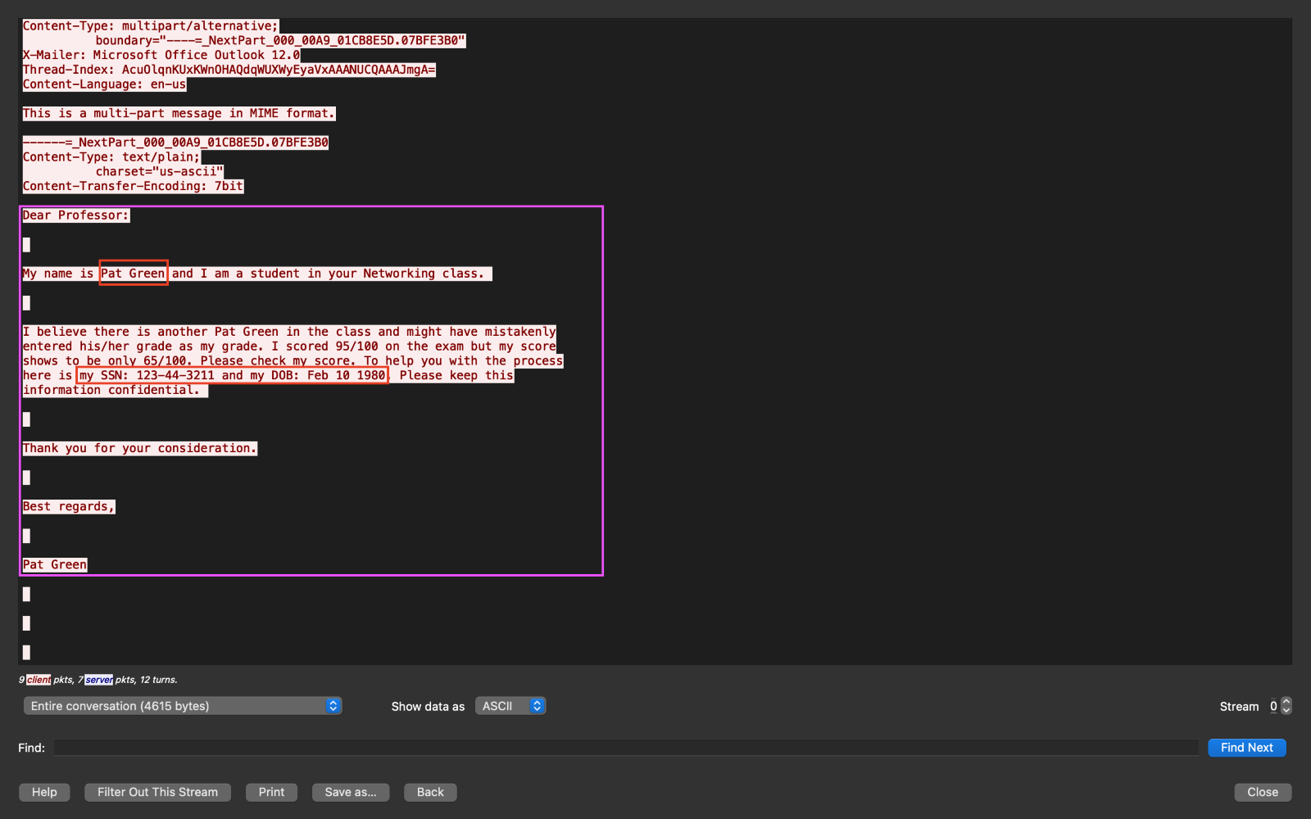

Section A, Question 3: Identify and list the IP address and port of the client machine (mail client).

In the square box, I used the “follow TCP stream” and filtered the message. It shows that ‘192.168.1.100’ is the client’s machine IP address and the port is ‘55012’.

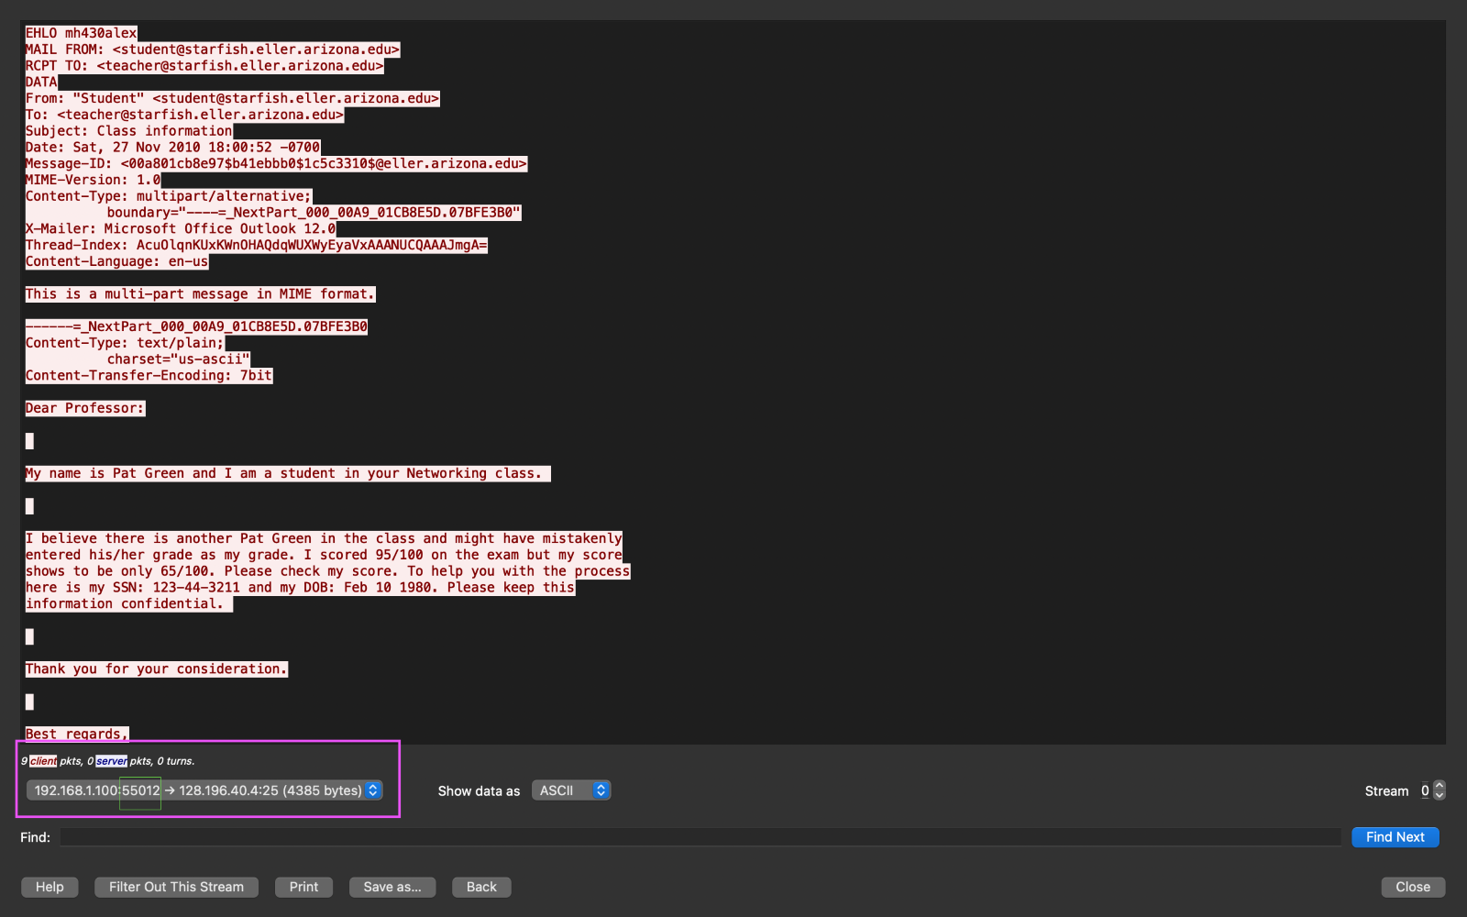  
Section A, Question 4: Identify and list the IP address and port of the host machine (mail server).

In the square box, I used the “follow TCP stream” and filtered the message. It shows that ‘128.196.40.4’ is the host machine IP address and the port is ‘25’.

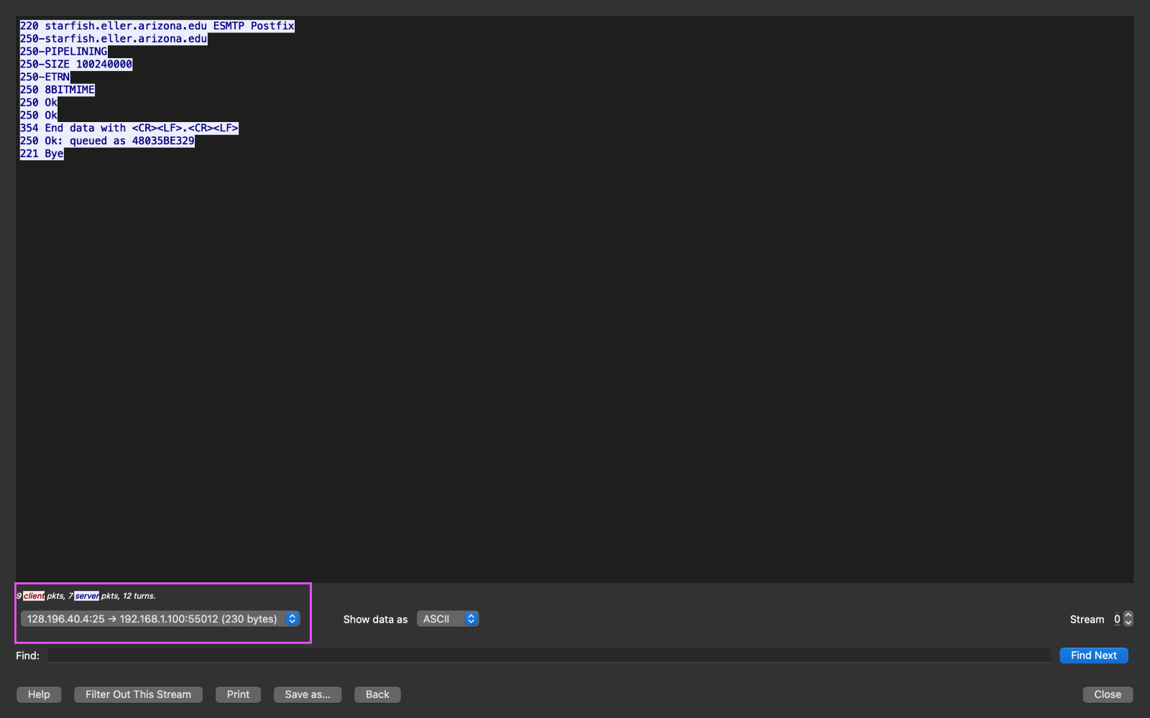

Section A, Question 5: Will the recipient of this message use SMTP to retrieve this e-mail from the server? Why or why not?

The receiver’s mail server will receive the message in SMTP, but the recipient client will receive the message as an IMAP or POP. SMTP always used to send e-mail between mail servers but POP retrieves messages from mail server, then deletes on server and IMAP retrieves messages from mail server, messages may remain on server.

Section B, Question 1: Identify the version of HTTP used by the client’s browser and the version used by the web server.

The client’s browser version is ‘Wget/1.12 (linux-gnu)’ and the version used by the web server is ‘nginx/0.8.53’.

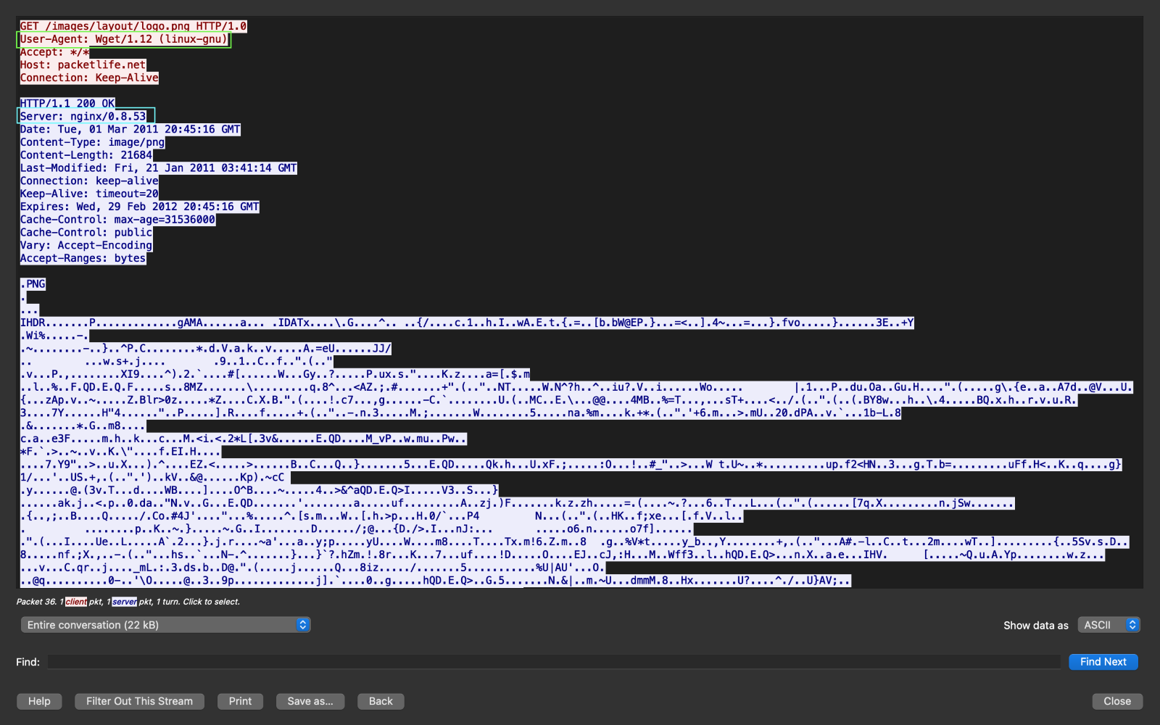  
Section B, Question 2: Identify and list the IP address and port of the host machine (web server).

In the square box, I used the “follow HTTP stream” and filtered it. The web server IP is ‘174.143.213.184’ and the port is ‘80’.

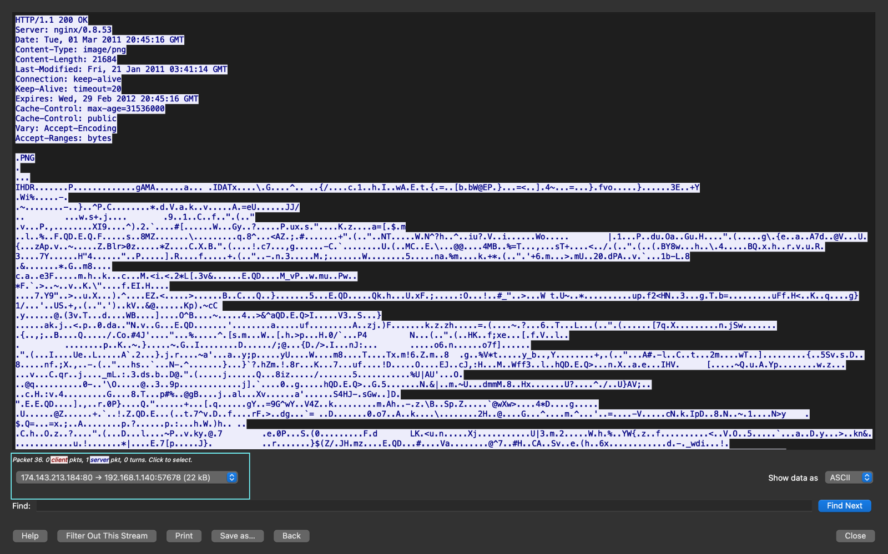

Section B, Question 3: Identify and list the IP address and port of the client machine (web browser).

In the square box, I used the “follow HTTP stream” and filtered it. The IP address from the client's machine is ‘192.168.1.140’ and the port is ‘57678’.

